**Declaration of Conformity (DoC)**

#### We,Shenzhen DOKE Electronic Co.,Ltd.

##### 801, Building3, 7th Industrial Zone, Yulv Community, Yutang Road, Guangming District, Shenzhen, China.

**Declare that the DoC is issued under our sole responsibility and belongs to the following product(s):**

**Product Type: Trademark**： **Model Number( s):**

Tablet PC

Blackview, OSCAL

Tab60 WiFi, Tab A6 Kids, Pad 60 Kids

(Name of product, type or model, batch or serial number)

System components:

FPCAntenna:BT/Wi-Fi2.4G:1.9dBi; WIFI5G:1.3dBi;

Adapter 1 :

Model: HJ-0502000-EU

Input: 100-240V~50/60Hz 0.3A Output: 5.0V 2.0A (10.0W)

Manufacturer: Shenzhen Huajin Electronics Co.,Ltd Adapter 2:

Model: QZ-01004EA00

Input: 100-240V~50/60Hz 0.3A Output: 5.0V 2.0A (10.0W)

Manufacturer: Guangdong Quanzhi Technology Co.,Ltd

RechargeableLi-ionBattery:

Model:Li2753130htt; Specification:DC 3.8V, 5100mAh,19.38Wh; Manufacturer: Shenzhen Huatiantong Technology Co.,Ltd.

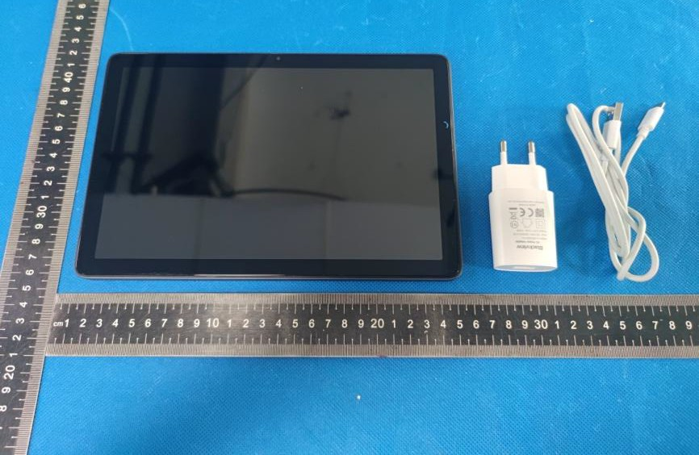

#### The object of the declaration described above is in conformity with the essential requirements of the relevant Union harmonization legislation: Radio Equipment Directive *RED (2014/53/EU)*.

**The following *harmonized* standards and technical specifications have been applied:**

**HEALTH & SAFETY (Art. 3(1)(a)):**

EN 50566:2017;

EN 62209-2:2010;

EN 62479:2010

EN IEC 62368-1:2020+A11:2020

**EMC (Art. 3(1)(b)):**

ETSI EN 301 489-1 V2.2.3 (2019-11)

ETSI EN 301 489-3 V2.1.1 (2019-03)

ETSI EN 301 489-17 V3.2.4 (2020-09) EN 55032:2015+A1:2020

EN 55035:2017+A11:2020

EN IEC 61000-3-2:2019+A1:2021 EN 61000-3-3:2013+A2:2021

**Radio Spectrum (Article 3.2):**

EN 300 328 V2.2.2 (2019-07);

EN 301 893 V2.1.1 (2017-05);

EN 300 440 V2.2.1 (2018-07);

**Notified Body Involved:**

**3.3(g) Emergency Services: DELEGATED REGULATION (EU) 2019/320**

Notified Body Name: Eurofins Electrical and Electronic Testing NA, Inc. Notified Body Number: 0980

Notified Body Assessment Performed: Module B/C on Article 3.1a, 3.1b, 3.2 EU-type examination certificate number: 3764-03-2025-250107

RF Specification:

|  |  |  |
| --- | --- | --- |
| **Function** | **Operation Frequency** | **Max RF**  **outputpower:** |
| BLE | 2402MHz-2480MHz | ＜10dBm |
| BT(BR+EDR) | 2402MHz-2480MHz | ＜10dBm |
| WIFI 802.11b/g/ n(HT20/40) | 802.11b/g/n/ax(20MHz):2412~2472MHz;  802.11n/ax(40MHz):2422~2462MHz | ＜20dBm |
| Wi-Fi 5.2G(802.11a/n20/n4  0/ac20/ac40/ac80) | 802.11a/n/ac/ax(20M):5180MHz~5240MHz  802.11n/ac/ax(40M):5190MHz~5230MHz  802.11 ac/ax(80MHz):5210MHz | ＜20dBm |
| Wi-Fi 5.8G(802.11a/n20/n4  0/ac20/ac40/ac80) | 802.11a/n/ac/ax(20M):5745MHz~5825MHz  802.11n/ac/ax(40M):5755MHz~5795MHz  802.11ac/ax(80MHz):5775MHz | ＜13.98dBm |

Tests for SAR are conducted using standard operating positions with the device transmitting at its

highest certified power level in all tested frequency bands. The maximum SAR values tested on this device when used in its normal position at the ear and when used close to the body (at a minimum distance of 5mm/0mm) are:

|  |  |  |
| --- | --- | --- |
| Max SAR Value(W/kg)  Limit is 2.0(W/kg) for 10-g | 10-g Body | 0.347W/kg |
| Limit is 4.0(W/kg) for 10-g | 10-g Member DAS | 0.347W/kg |

Technical file held by:Shenzhen DOKE Electronic Co., Ltd

801, Building3, 7th Industrial Zone, Yulv Community, Yutang Road, Guangming District, Shenzhen, China.

**Signed for and on behalf of:** Shenzhen DOKE Electronic Co., Ltd

**Name and Title:** zhang.liuwei/Manager

**Address:** 801, Building3, 7th Industrial Zone, Yulv Community, Yutang Road, Guangming District, Shenzhen, China.



### Signature of Authorized Person

2025-02- 25